**Objective**

**Curriculum Vita**

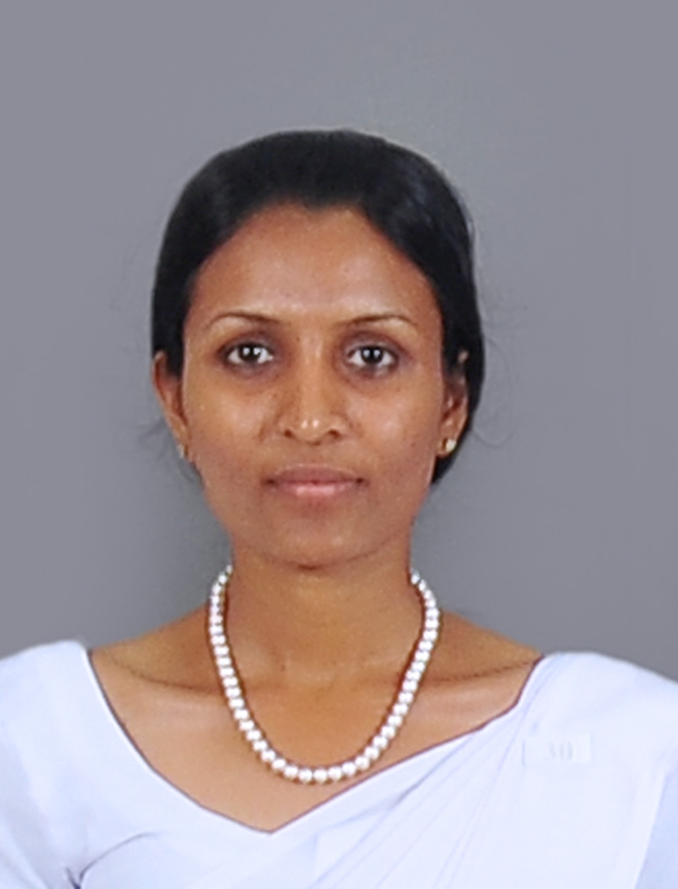

Improve my future life and contribute my optimum commitment in development of the relevant organization where I am working for, moreover my motherland.

|  |  |  |  |  |  |  |  |  |  |
| --- | --- | --- | --- | --- | --- | --- | --- | --- | --- |
| 1. **Personal Details** | | | | | | | | | |
| **1.1 Name with initials** | | K.P.M. Kumarawaththage | | | | | | | |
| **1.2 Names denoted by initials** | | Kumarawaththage Pranali Madhushanika | | | | | | | |
| **1.3 Postal Address** | | Isurusiri Estate, Matthegama,Ku/Bopitiya | | | | | | | |
| **1.5 Contact Details** | | **Mobile** | | 071-895945 / 078-5137806 | | | | | |
| **E-mail** | | Kwatthage@gmail.com | | | | | |
| **1.6 NIC Number** | | 897110784 V | | | | | | | |
| **1.7 Date of Birth** | | **Date** | | | **Month** | | | **Year** | |
| 29 | | | 07 | | | 1989 | |
| **1.8 Marital Status** | | Single | | | | | | | |
| **1.9 Religion** | | Chathalic | | | | | | | |
| **1.10 Nationality** | | Sri Lankan | | | | | | | |
| **1.11 District** | | Kurunegala | | | | | | | |
| 1. **Education Qualifications** | | | | | | | | | |
| **2.1 Higher Education** | | | | | | | | | |
| **Name of the Degree/ Diploma** | **University** | | **Qualification Obtained** | | | **Subjects** | | |
|
| B.A.(Special)  Geography | University of Sabaragamuwa | | Pending Result . | | | **Medium:** English | | |
| **Major** | Geography | |
| **Minor** | Sociology | |

|  |  |  |  |  |  |  |  |
| --- | --- | --- | --- | --- | --- | --- | --- |
| 1. **School Attended** | | | | | | | |
| **School:** Ku/ Sandalanka Central Collage | | | | | | | |
| **G.C.E. (O/L) Year: 2005** | | | | **G.C.E (A/L) Year :2009** | | | |
| **Subject** | | **Grade** | | **Subject** | | | **Grade** |
| **1.** Chathalic | | **A** | | **1.** Sinhala | | | **A** |
| **2.** Health and Physical Education | | **A** | | **2.** History | | | **B** |
| **3.** Sinhala | | **B** | | **3.** Political Sicience | | | **C** |
| **4.** Mathematics | | **S** | |
| **5.** Social Studies & History | | **C** | |
| **6.** Science & Technology | | **S** | |
| **7.** English | | **S** | |
| **8.** Home Science | | **C** | |
| **9.** Music | | **B** | |
| **10.** History | | **C** | |
| 1. **Propetional qualification** | | | | | | | |
| Completed the Certificate in Computer & Information Technology National Youth  Service Council with six month trainee period in **Wayamba University of Sri Lanka**. | | | | | | | |
| 1. **LINGUISTIC SKILLS (Indicate level of proficiency by stating Very Good, Good, Moderate, Basic)** | | | | | | | |
| **Language** | **Understand** | | **Speak** | | **Read** | **Write** | |
| **Sinhala** | Very good | | Very good | | Very good | Very good | |
| **English** | Good | | Good | | Good | Good | |
| **Tamil** | - | | - | | Basic | Basic | |
| **German** | - | | - | | Basic | Basic | |

|  |  |  |
| --- | --- | --- |
| 1. **ICT literacy** | | |
| Microsoft Word, Excel, Access and PowerPoint  Internet and E-mail | | |
| 1. **Extracurricular activities**   **(Leadership, Membership, Sports and any other extracurricular activities)** | | |
| * Active member of the school Art society. * Active member of the Sundy School Art society. * Active member of the school athletic games team. | | |
| 1. **Non related referees** | | |
| **Name & Designation** | **Address** | **Contact No** |
| Miss: Thakshila Senevirathne *(Lecturer in Economics)* | Department of Social Science,  Faculty of Social Sciences and Languages,  Sabaragamuwa University of Sri Lanka. | Mobile:  0718486076 |
| Mr: H.W.P.L. Wikramarachchi | “Lakmali”,  Matthegama,  Ku/Bopitiya. | Mobile: 0719464540 |
| 1. **Declaration** | | |
| I certify that the statements made by me are all true, complete and correct to the best of my knowledge.    24/09/2015 Signature Date | | |